Day | Class | Class | Class | Class | Class
Monday
Monday | Mini Karate  3-6 years  4-4:30pm | Jr Karate  7-11 years  4:35-5:15pm | Senior Karate  12yrs-Adult  5:20-6:15pm | Advanced Students  6:15-6:45pm
Tuesday
Tuesday | Mini Karate  3-6 years  4-4:30pm | Jr Karate  7-11 years  4:35-5:15pm | Complete Beginners 12yrs-Adult  5:20-6:00pm
Wednesday
Wednesday |  |  |  | Senior Karate  12yrs-Adult  5-6pm
Thursday
Thursday | Mini Karate  3-6years  4-4:30pm | Jr Karate  7-11 years  4:35-5:15pm | Senior Karate  12yrs-Adult  5:20-6pm | Advanced Students  6-6:30pm
Friday
Saturday | Mini Karate  3-6yrs  8:00-8:30am | Jr Karate  7-11 years  8:35-9:15am | Open Syllabus Class  12yrs-Adult  9:20-10:20am
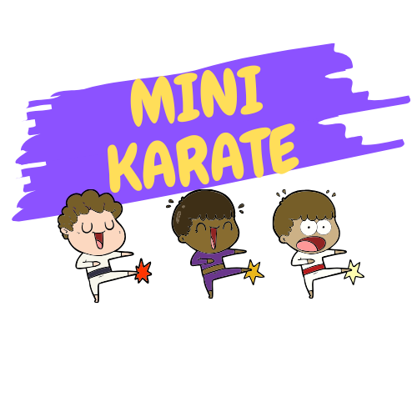
Timetable 2022

